**Finding the best place to open a bar in Vitória/ES – Brazil**

Roberto Carlos do Nascimento Siqueira

November 4, 2020

1. **Introduction**
   1. **Background**

**Vitória over the years is in the top 10 cities to live. The city is an island and also has a continental part. It’s an old city with 469 years old. The city population is small compared with other cities and capitals. With only 363 thousand habitants, Vitória is being considered as the city with the best public services as education and health in Brazil. Some business are not allowed to have in specifics regions due the Urban Director Plan (PDU, in portuguese). This plan limit some areas according to specifics rules. It’s not part of the scope of this work. This work is a final project of the IBM Data Science Professional certification. As the city has some beach, the first place to consider to open a bar would be there. Although, the litoral has some kiosk controlled by the city hall and it’s not allowed to construct anything there. This report details the process to finding a best place to have a bar considering main factors as per capita income, others bars and so on.**

* 1. **Target Audience**

**The target audience is people interested in open a bar in Vitória/ES-Brazil.**

1. **Data**

The data to be used in this analysis will be provided by three sources:

1. **Foursquare**
2. **“Vitória Bairro a Bairro – 2013” report** (<http://legado.vitoria.es.gov.br/regionais/geral/publicacoes/Vitoria_bairro_bairro/Vit%C3%B3ria_bairro_%20a_bairro.pdf>)
3. **“Administrative regions – Vitória” report** (<http://legado.vitoria.es.gov.br/regionais/geral/dados/reg_adm_ger.pdf>)
   1. **Foursquare**

**The Foursquare will be responsible to show others main bars in Vitória.**

* 1. **“Vitória Bairro a Bairro – 2013” report**

This report will provide some informations as Male and Female concentration per region, age range and income class.

* 1. **“Administrative regions – Vitória” report**

Vitória is divided in seven administrative regions. This information will be acquired from this report.

1. **Methodology**
   1. **Data collection, preparation, exploration and visualization**
      1. **Foursquare**

**Using the jupyter notebook available in the Git repository is possible to get all kind of bars in Vitória and theirs locations. The most relevant bars are more concentrate in the towncity. This information is available as a panda dataframe and a graph shown below:**

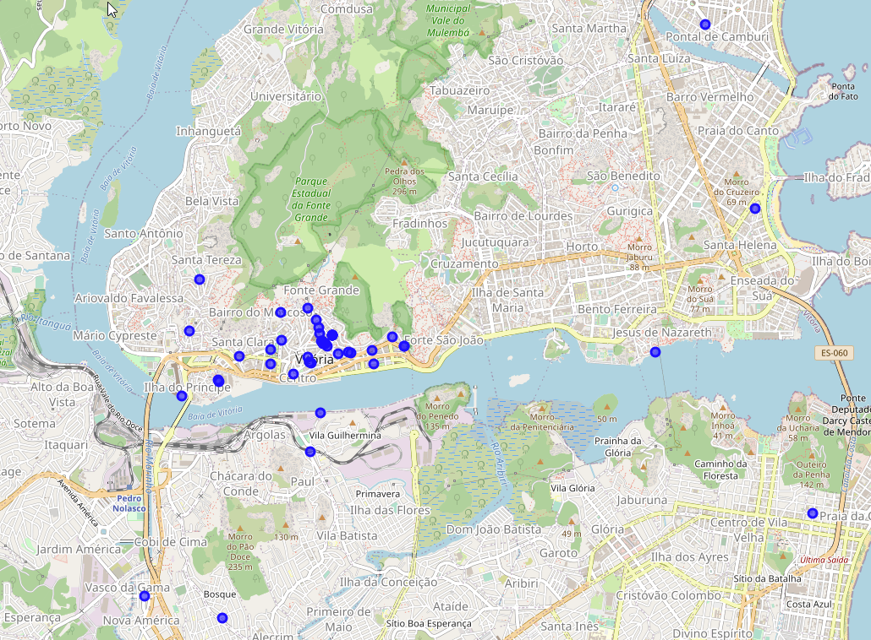

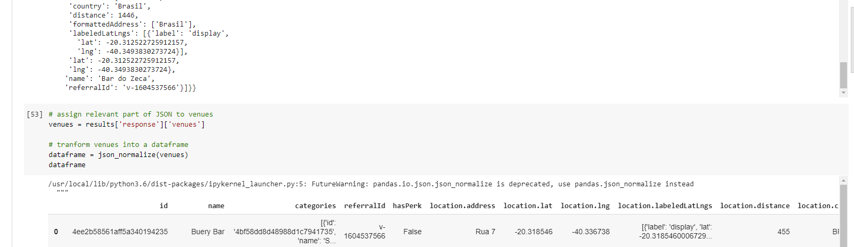

* + 1. **“Vitória Bairro a Bairro – 2013” report**

The data was collected and treated as the image below:

Before:

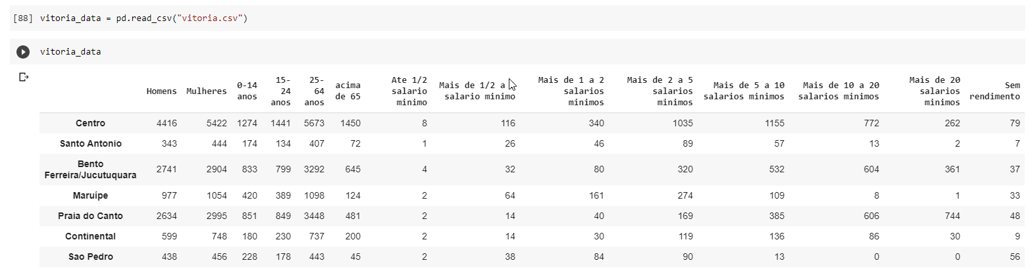

**After:**

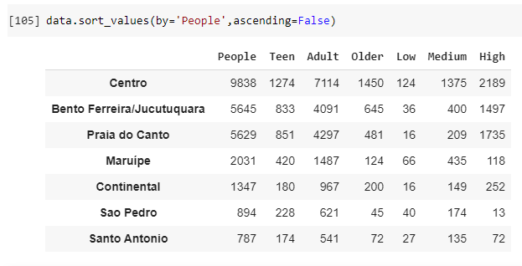

**As can be noted the “Centro” is the place with more concentration of people, followed by “Bento Ferreira/Jucutuquara” and “Praia do Canto”.**

**It’s possible to noted in the figure below that the “Centro” is the region with more income concentration, followed by “Praia do Canto” and “Bento Ferreira/Jucutuquara”:**

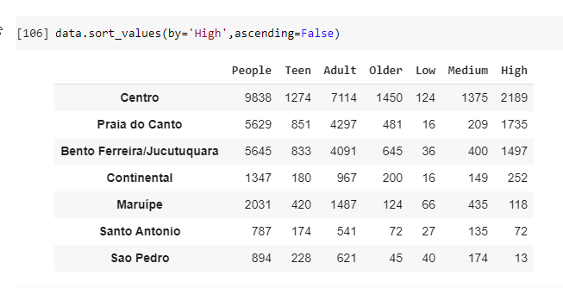

**Using K-means we can note that “Bento Ferreira/Jucutuquara” and “Praia do Canto” are in the same cluster. We can choose one or other:**

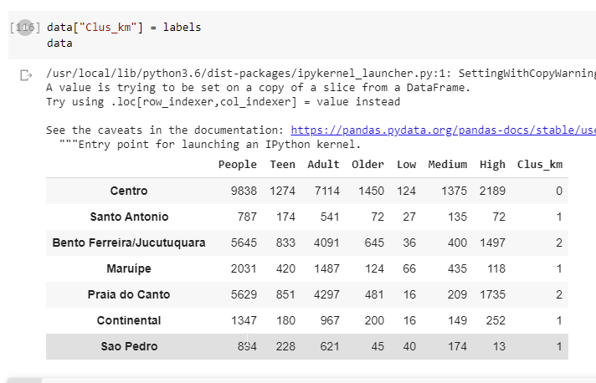

1. **Results**

**Crossing with data from Foursquare it’s possible to see that there is no significant places there. Due this, the best place to open a bar in Vitória, according to the data available is “Praia do Canto” that has the highest income.**